Create the Database
CREATE DATABASE ProductDB;
Use the Database
USE ProductDB;

Create the Products Table
CREATE TABLE Products
(
ProductID INT PRIMARY KEY,
ProductName VARCHAR(50),
Category VARCHAR(50),
Price DECIMAL(10,2)
);

Insert Sample Data
INSERT INTO Products VALUES
(1,'Laptop A','Electronics',70000),
(2,'Laptop B','Electronics',65000),
(3,'Laptop C','Electronics',70000),
(4,'Phone A','Electronics',50000),
(5,'Shirt A','Clothing',2000),
(6,'Shirt B','Clothing',1800),
(7,'Shirt C','Clothing',2000),
(8,'Jeans A','Clothing',2500),
(9,'Book A','Books',500),
(10,'Book B','Books',450),
(11,'Book C','Books',500),
(12,'Book D','Books',300);

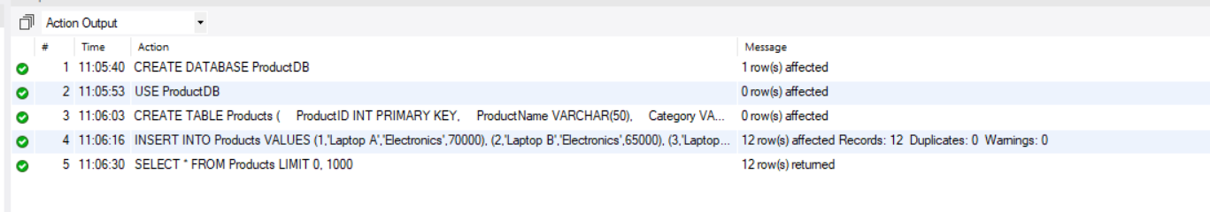

Display the Table
SELECT * FROM Products;
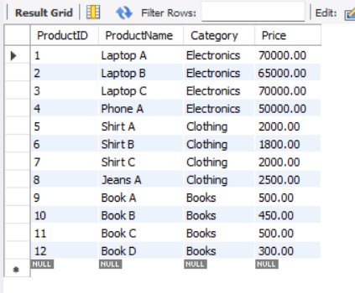

ROW_NUMBER() - Assigns a unique number to each row within each category.
SELECT
ProductID,
ProductName,
Category,
Price,
ROW_NUMBER() OVER
(
PARTITION BY Category
ORDER BY Price DESC
) AS RowNumber
FROM Products;
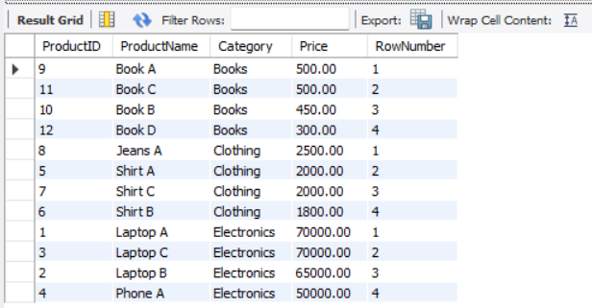

RANK()
SELECT
ProductID,
ProductName,
Category,
Price,
RANK() OVER
(
PARTITION BY Category
ORDER BY Price DESC
) AS RankNumber
FROM Products;
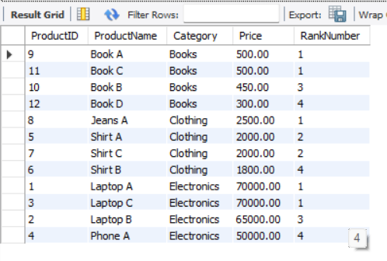

DENSE_RANK()
SELECT
ProductID,
ProductName,
Category,
Price,
DENSE_RANK() OVER
(
PARTITION BY Category
ORDER BY Price DESC
) AS DenseRank
FROM Products;
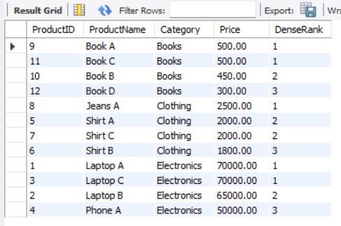

Top 3 Most Expensive Products Using ROW_NUMBER()
SELECT *
FROM
(
SELECT
ProductID,
ProductName,
Category,
Price,
ROW_NUMBER() OVER
(
PARTITION BY Category
ORDER BY Price DESC
) AS RowNumber
FROM Products
) AS RankedProducts
WHERE RowNumber <= 3;
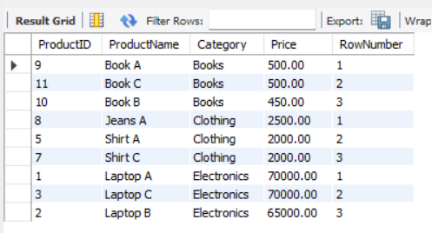

Top 3 Using RANK()
SELECT *
FROM
(
SELECT
ProductID,
ProductName,
Category,
Price,
RANK() OVER
(
PARTITION BY Category
ORDER BY Price DESC
) AS RankNumber
FROM Products
) AS RankedProducts
WHERE RankNumber <= 3;
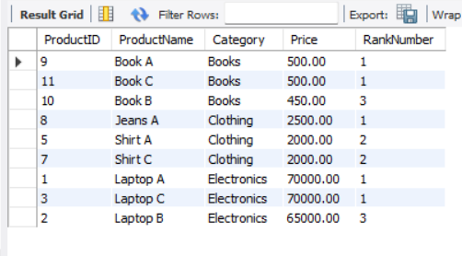
Top 3 Using DENSE_RANK()
SELECT *
FROM
(
SELECT
ProductID,
ProductName,
Category,
Price,
DENSE_RANK() OVER
(
PARTITION BY Category
ORDER BY Price DESC
) AS DenseRank
FROM Products
) AS RankedProducts
WHERE DenseRank <= 3;
